Phonics Stretch – oo sound
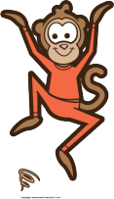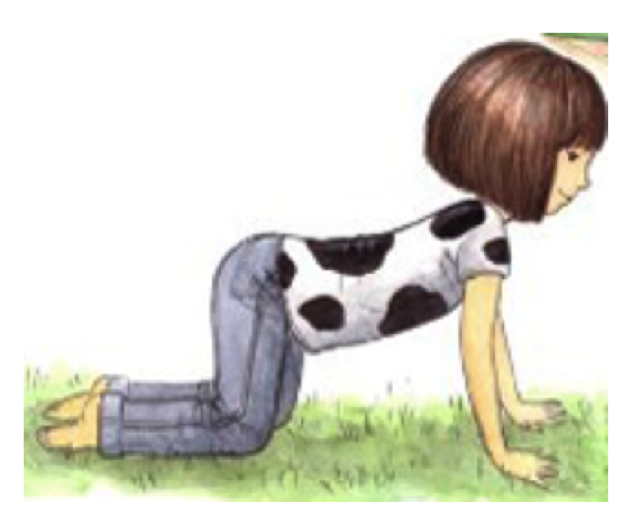
Short /oo/ (book) long /oo/(moo)

Click on the pictures and it will link you to monkey and cow sound.
Click here to see a video demonstration of this game!

- Cut out the /oo/ words and place upside down in front of you.
- Flip over one card at a time.
- Read the word aloud.
- If it is a long /oo/ sound, pretend you are a cow stretching its back (see picture above) and say the word you turned over while stretching (ex: while stretching say “moo, moo, moo”).
- If it is a short /oo/ sound, jump like a monkey and say the word three times (for example say “foot, foot, foot”).
- Keep flipping over the words until you have read them all.
- Once you finish, celebrate by doing 20 jumping jacks.

foot | bloom | tool | moon
cookie | took | zoom | hoodie
tooth | hook | rooster | spoon
zoom | cook | room | shook

